WEB BANNER ABSOLUT VODKA 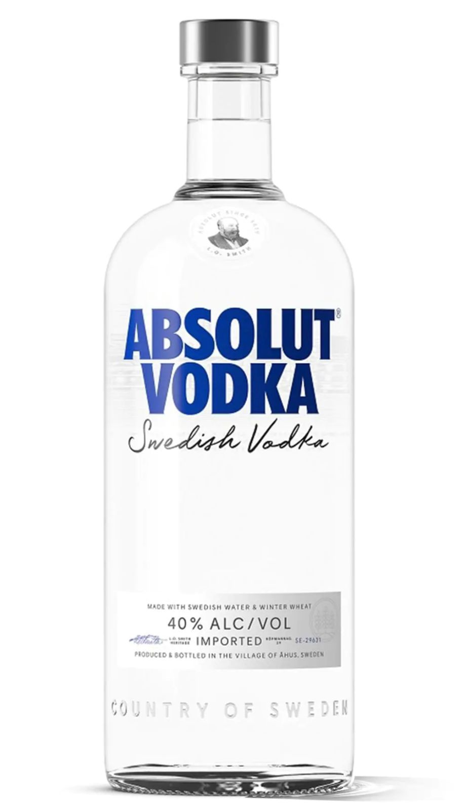 Take a look at my unique collection
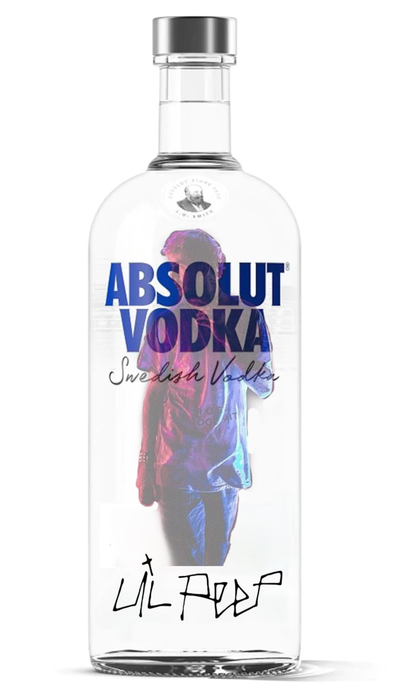
ABSOLUT PEEP
this WEB BANNER PROMOTES MUSIC AS AN ESSENTIAL PART OF OUR LIVES INDICATING PRESENCE OF PEEP (A FAMOUS SINGER) ON THE BOTTLE.

fORMAT: jpg dIMENSION: 918X1600
qUALITY: mAX. fILE SIZE: 73.2KB

absolut cricket
tHIS WEB BANNER HIGHLIGHTS icc CRICKET WORLD CUP, SHOWING IMAGE OF A PLAYER IN MULTICOLOR REPRESENTING ALL THE COUNTRIES.

fORMAT: jpg dIMENSIONS:918X1600

qUALITY: mAX. fILE SIZE:72.8KB

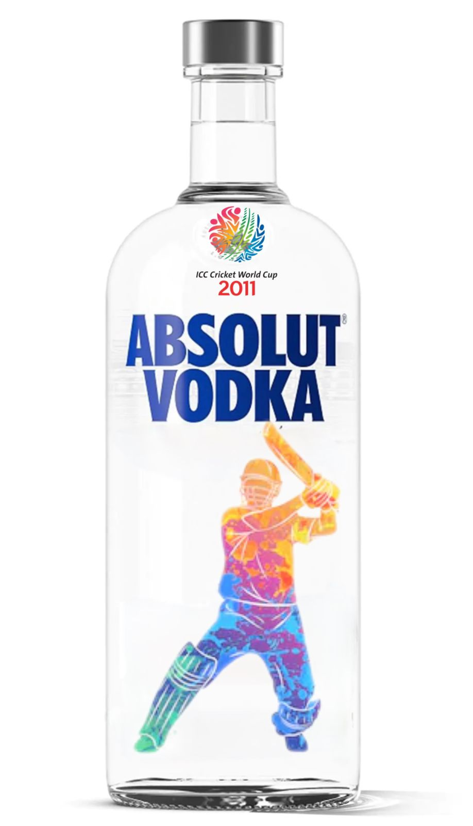
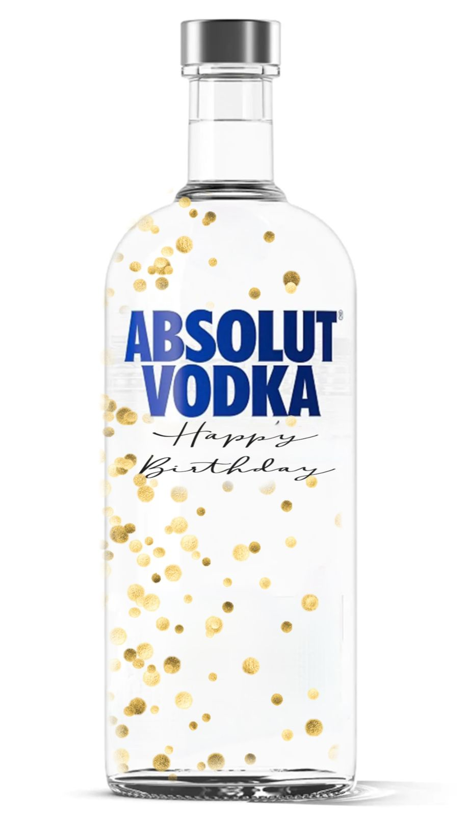
absolute birthday
tHIS IS REPRESENTING BIRTHDAY THEME. THE BOTTLE IS SPRINKLED WITH GOLDEN GLITTER

fORMAT:JPG dIMENSION:918X1600
qUALITY:MAX fILE sIZE:71.6KB

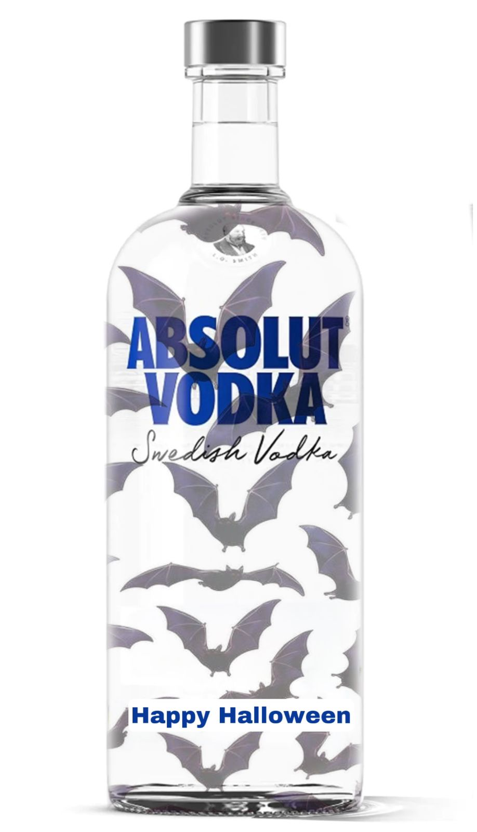
absolut halloween
tHIS WEB BANNER IS SPECIALLY GRAFTED FOR THE SPOOKY SEASON. tHE BATS ARE APTLY PLACED WISHING HAPPY HALLOWEEN.

fORMAT: JPG dIMENSION:918X1600
QUALITY:MAX FILE SIZE:81.3

